Questions:

- What are the different types of perceptron?
- What is the use of the Loss functions?

What is the role of the Activation functions in Neural Networks?

List down the names of some popular Activation Functions used in Neural Networks.

What do you mean by Cost Function?

How to initialize Weights and Biases in Neural Networks?

Why is zero initialization of weight, not a good initialization technique?

Explain Gradient Descent and its types.

Explain the different steps used in Gradient Descent Algorithm.

What is the difference between Forward propagation and Backward Propagation in Neural Networks?

Answers:
- There are two types of perceptrons:
1. Single-Layer Perceptrons: Single-layer perceptrons can learn only linearly separable patterns.
2. Multilayer Perceptrons: Multilayer perceptrons, also known as feedforward neural networks having two or more layers have a higher processing power.

- The loss function is used as a measure of accuracy to identify whether our neural network has learned the patterns accurately or not with the help of the training data.
This is completed by comparing the training data with the testing data.
Therefore, the loss function is considered as a primary measure for the performance of the neural network. In Deep Learning, a good-performing neural network will have a low value of the loss function at all times when training happens.

- The reason for using activation functions in Neural Networks are as follows:
- The idea behind the activation function is to introduce nonlinearity into the neural network so that it can learn more complex functions.
- Without the Activation function, the neural network behaves as a linear classifier, learning the function which is a linear combination of its input data.
- The activation function converts the inputs into outputs.
- The activation function is responsible for deciding whether a neuron should be activated i.e, fired or not.
- To make the decision, firstly it calculates the weighted sum and further adds bias with it.
So, the basic purpose of the activation function is to introduce non-linearity into the output of a neuron.

- Some of the popular activation functions that are used while building the deep learning models are as follows:
- Sigmoid function
- Hyperbolic tangent function
- Rectified linear unit (RELU) function
- Leaky RELU function
- Maxout function
- Exponential Linear unit (ELU) function
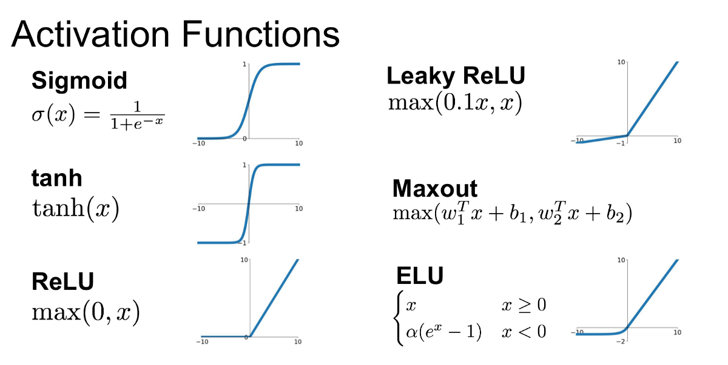

- While building deep learning models, our whole objective is to minimize the cost function.
A cost function explains how well the neural network is performing for its given training data and the expected output. It may depend on the neural network parameters such as weights and biases. As a whole, it provides the performance of a neural network.

- Neural network initialization means initialized the values of the parameters i.e, weights and biases. Biases can be initialized to zero but we can’t initialize weights with zero.
Weight initialization is one of the crucial factors in neural networks since bad weight initialization can prevent a neural network from learning the patterns.
On the contrary, a good weight initialization helps in giving a quicker convergence to the global minimum. As a rule of thumb, the rule for initializing the weights is to be close to zero without being too small.

- If we initialize the set of weights in the neural network as zero, then all the neurons at each layer will start producing the same output and the same gradients during backpropagation.
As a result, the neural network cannot learn anything at all because there is no source of asymmetry between different neurons. Therefore, we add randomness while initializing the weight in neural networks.

- Gradient Descent is an optimization algorithm that aims to minimize the cost function or to minimize an error. Its main objective is to find the local or global minima of a function based on its convexity. This determines in which direction the model should go to reduce the error.
There are three types of gradient descent:
- Mini-Batch Gradient Descent
- Stochastic Gradient Descent
- Batch Gradient Descent
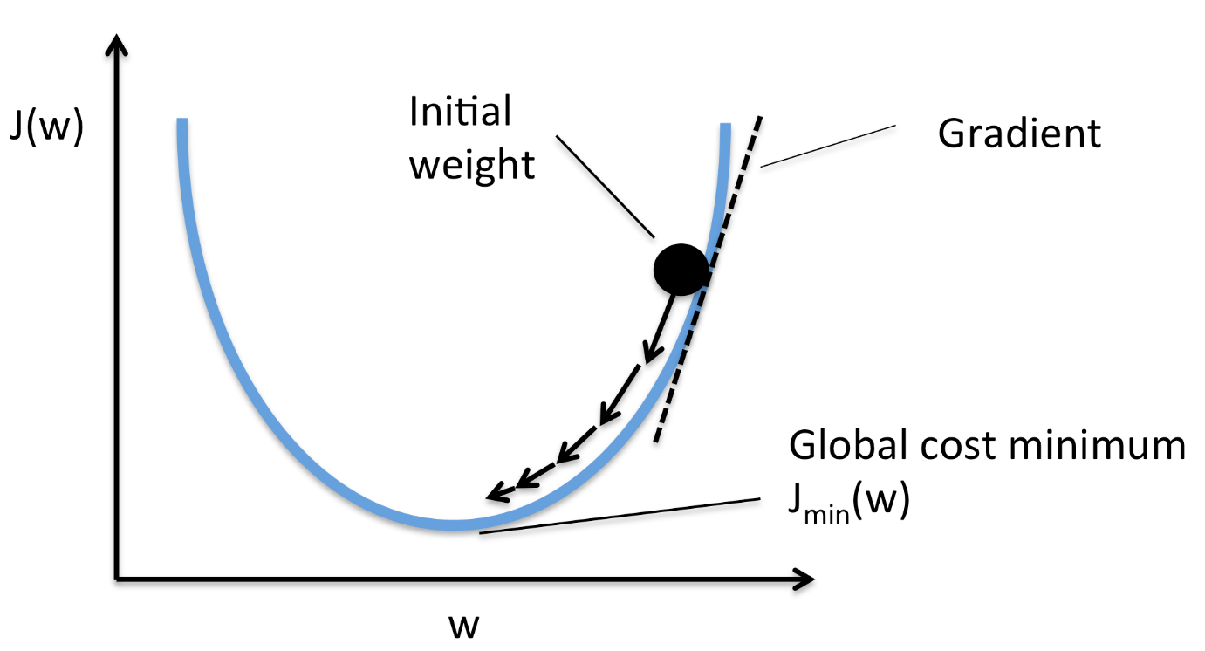

- The five main steps that are used to initialize and use the gradient descent algorithm are as follows:
- Initialize biases and weights for the neural network.
- Pass the input data through the network i.e, the input layer.
- Compute the difference or the error between the expected and the predicted values.
- Adjust the values i.e, weight updation in neurons to minimize the loss function.
- We repeat the same steps i.e, multiple iterations to determine the best weights for efficient working.

- Difference between Forward Propagation and Backward Propagation:
- Forward propagation: The input is fed into the network. In each layer, there is a specific activation function and between layers, there are weights that represent the connection strength of the neurons. The input runs through the individual layers of the network, which ultimately generates an output.
- Backward propagation: an error function measures how accurate the output of the network is. To improve the output, the weights have to be optimized. The backpropagation algorithm is used to determine how the individual weights have to be adjusted. The weights are adjusted during the gradient descent method.

